**Using ScrambledEggs Macro by Dr. Fayyaz Minhas, PIEAS.**

**GPL v 2 Licensed Software.**

**If you use it or redistribute it after changes, please be sure to include and acknowledge the**

**original creator of this macro. Thanks!**

**Scrambled Eggs Macro by Dr. Fayyaz ul Amir Afsar Minhas**

**(afsar at pieas dot edu [dot] pk), Senior Scientist, PIEAS, Islamabad, Pakistan April 8, 2015.**

**Objective: Shuffle MCQ Option tables without affecting formatting.**

**Warranties and support: None. Report bugs to email above.**

ScrambledEggs is a macro that shuffles the order of answers to MCQs in a word document and generates a solution key automatically. You can use this document as a template for generating your own MCQs.

**Making the MCQ Exam**

First we need to make a master copy MCQ exam in MS word. To do this each question must be numbered using bullets and numbering in MS word and the table options should also be numbered using bullets and numbering in MS word. The correct answer should always be put as the first option in the table. Below are a few examples that illustrate this.

1. What is the answer to this question? I have put the correct answer at location A. This table will be shuffled. The numbering style (A, B, C, D) has been inserted using bullets and numbering.

|  |  |
| --- | --- |
| 1. The correct answer | 1. Choice 1 |
| 1. Choice 2 | 1. Choice 3 |

1. Tables of different styles and number of options are supported.

|  |
| --- |
| 1. The correct answer |
| 1. Choice 1 contains an image |
| 1. Choice 2 involving symbols β£ |
|  |
| 1. Choice 4 |

1. Here is a table that I do not want to shuffle. I have nestled it inside a table of 1x1 and removed the borders of the outer table.

|  |  |  |  |  |
| --- | --- | --- | --- | --- |
| |  |  | | --- | --- | | 1. The correct answer | 1. Choice 1 | | 1. Choice 2 | 1. Choice 3 | |

**Running the ScrambledEggs Macro**

**Here is a video on how to add and run any macro in MS word:** [**https://www.youtube.com/watch?v=Z0Oo7G9BLPU**](https://www.youtube.com/watch?v=Z0Oo7G9BLPU) **OR** [**https://www.youtube.com/watch?v=jsUjHBcc29I**](https://www.youtube.com/watch?v=jsUjHBcc29I)

**Below is a description of this procedure:**

Once you are done making your exam in this way, simply go to View > Macros and the following dialog will show. Alternatively, you can write “Macros” in your search help box in MS Word and click on “View Macros” there.

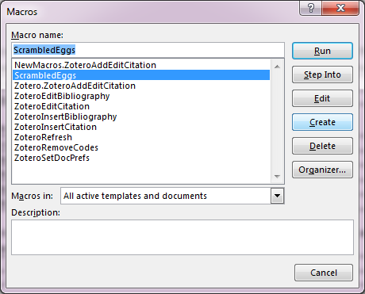

Type ScrambledEggs in the macro name if it is not already there and hit “create” to open the VBA editor and paste the contents of scramble.vb file into the VBA editor (No need for this step if you are using this document as a template and have macros enabled in MS word).

If ScrambledEggs is already there, then you should click “ScrambledEggs” and edit to open the VBA Editor.

The VBA Editor looks like this:

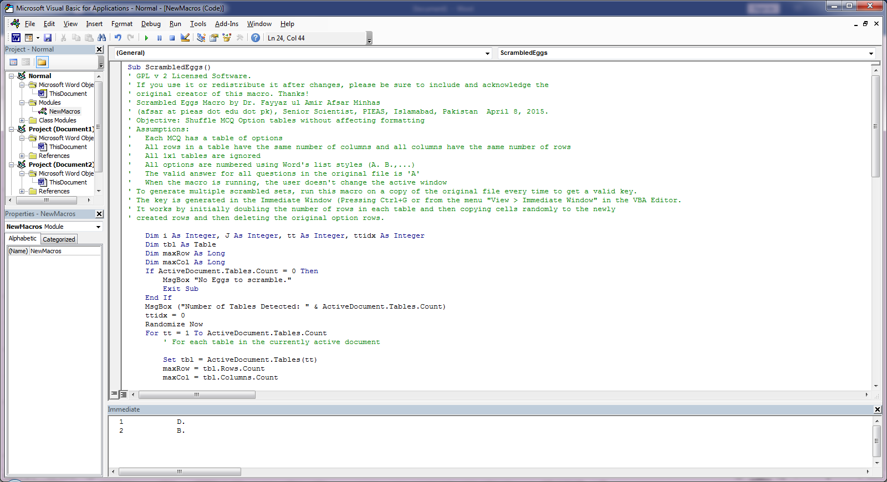

If you want to generate three different copies, save the master file into three word files as running the macro will change the order in the file in which the macro runs.

Then simply click “Run” which will show the number of tables in the document and then shuffle the MCQs and generate the **key** in the Immediate output at the bottom. On conclusion, it will show how many tables were scrambled. If the Immediate window is not visible, it can be shown by pressing Ctrl+G in the VBA editor or going to View>Immediate Window in the VBA editor. Please do not switch windows while the macro is running.